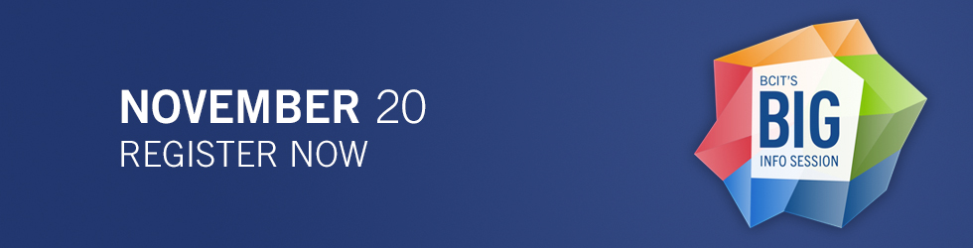

About BIG Info
Twice per year, BCIT hosts its “BIG Information Session & Program Expo” at the main campus in Burnaby. This free event is open to everyone and provides a unique opportunity for you to find out more about BCIT’s full-time programs and part-time courses and programs all in one place, at one time.
The BIG Info event gives you the opportunity to hear from successful BCIT grads, meet with faculty, staff and program advisors, and find out why employers hire BCIT grads.
The next BIG Info Session & Program Expo date is Wednesday, November 20 from 5:00 – 8:00 p.m.

Welcome sessions
Learn about BCIT’s unique education path and what we have to offer. Welcome sessions include student and alumni testimonials, and great prize giveaways.
These sessions will be held in SE6 Room 233 (Telus Theatre) at 5:00 p.m. and 6:30 p.m.

Getting Here
Our BIG Info & Program Expo event is held at our Burnaby Campus at 3700 Willingdon Avenue, Burnaby, BC in buildings SW1, SE2 & SE6 Great Hall & Town Square Rooms.

Public transit
To get to the Burnaby Campus, take bus #25 (Brentwood Mall / UBC); or #130 (Metrotown / Hastings / Kootenay Loop) and exit at BCIT’s main entrance on Willingdon Avenue. Call Translink’s customer information centre at 604-953-3333 or visit the Translink website for more details.

Drive
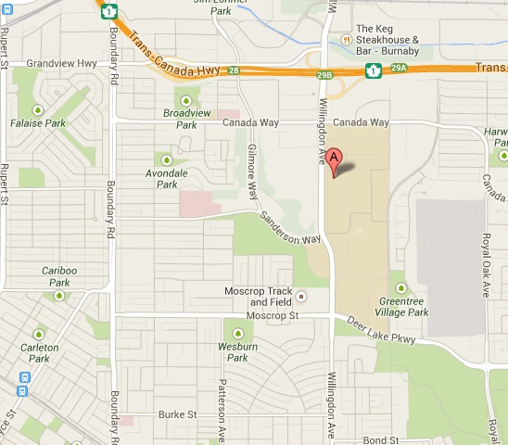
BCIT Burnaby Campus
Get detailed directions on how to drive to our Burnaby campus from any location by using Google Maps.
Parking will be complimentary during this event, starting at 4:30 p.m.

Parking Access Routes
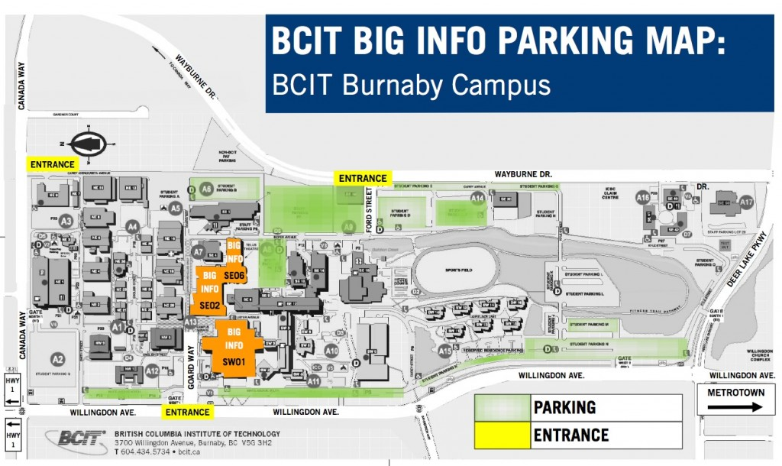
BCIT Big Info Parking Map

